UNIVERSITY OF RWANDA
WEB DESIGN TECHNICAL REPORT

AGRILINK AGRICULTURAL MARKETPLACE SYSTEM
PROJECT TECHNICAL REPORT

Name: MUNEZERO Agael
Registration Number: 225058843
Faculty: Computer Engineering

Report Contents
- Chapter 1: Introduction
- Chapter 2: System Analysis and Design
- Chapter 3: Implementation
- Chapter 4: Conclusion and Recommendations

Chapter 1: Introduction

1.1 Historical Background
Agriculture supports food supply and income for many communities. Farmers, buyers and transport providers often need faster ways to exchange product, order and delivery information. AgriLink was created as a simple web platform that connects these groups in one system.

1.2 Problem Statement
Agricultural trade may be slowed by limited market information, manual stock records and weak coordination of deliveries. AgriLink provides role-based dashboards for managing produce, orders, transport jobs and administrative review.

1.3 Objectives
The main objective is to develop a simple agricultural marketplace using basic HTML, CSS and JavaScript.
- Allow users to log in according to their role.
- Allow buyers to browse produce and place orders.
- Allow sellers to add, update and monitor products and orders.
- Allow transport providers to accept jobs and update delivery status.
- Allow administrators to review orders, refunds, sellers and transport companies.

1.4 Expected Outcome and Importance
The result is a working educational prototype that demonstrates forms, dashboards, search, status updates and browser storage. It improves the organization of information between agricultural market participants.

Chapter 2: System Analysis and Design

2.1 System Analysis

2.1.1 Intended Users
- Buyers searching and ordering agricultural products.
- Sellers managing produce, stock and customer orders.
- Transport providers handling delivery jobs.
- Administrators supervising platform records and refunds.

2.1.2 Functional Requirements
Function | Purpose
Login and role selection | Open the correct dashboard for Buyer, Seller, Transport or Admin.
Product management | Add or update produce, stock, unit, price, grade and availability.
Order management | Place orders, calculate totals and track order status.
Transport management | Accept jobs and update delivery progress.
Administration | Review orders and refunds, verify sellers and manage transport companies.
Search and filtering | Find records and filter dashboard sections.

2.2 System Design
HTML provides page content, CSS controls appearance and JavaScript manages interaction. Demo records and user sessions are stored in browser localStorage.
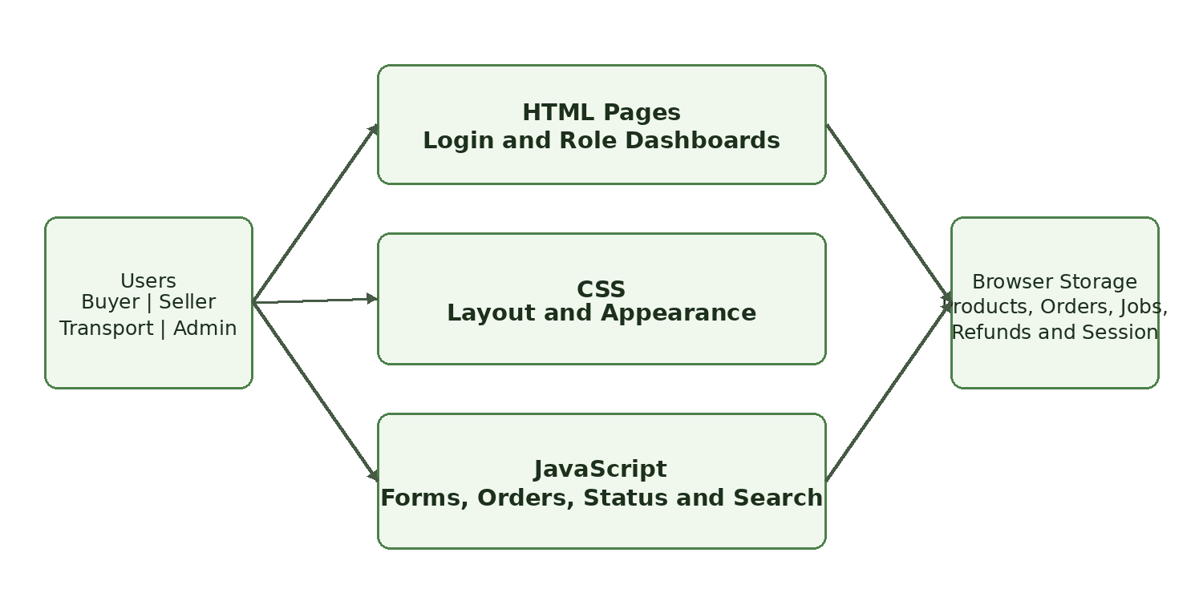
Figure 1: High-level architecture.

2.2.1 Main User Flow
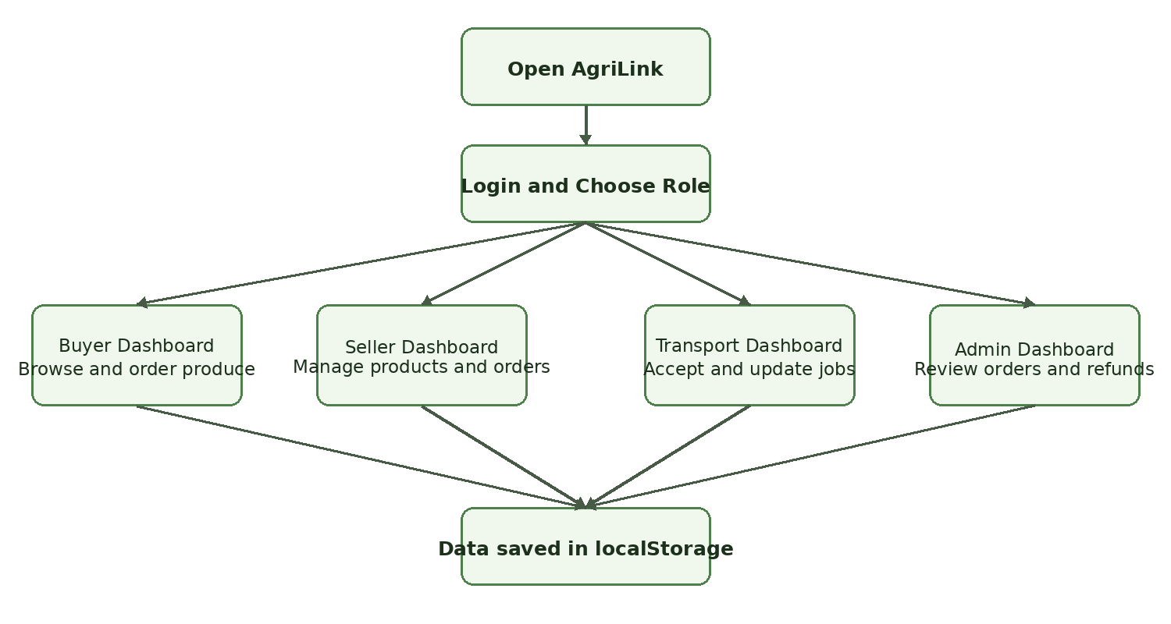
Figure 2: Role-based user flow.

2.2.2 Data Design
Record | Main fields | Relationship
User Session | User name or email, role | Determines the active dashboard.
Product | ID, name, seller, stock, unit, price, grade, status | A seller manages products; buyers order them.
Order | ID, buyer, seller, produce, quantity, total, location, status | Connects buyer, seller and transport.
Transport Job | ID, order, route, company, status | Represents delivery work.
Refund | ID, order ID, reason, amount, status | Reviewed by the administrator.
Directory | Seller or transport company, details, status | Managed by the administrator.

Chapter 3: Implementation

3.1 Technologies
The project uses basic HTML, CSS and JavaScript. The pages share one stylesheet and JavaScript file, while localStorage keeps the demonstration data and signed-in role.

3.2 Main Pages
Page | Main purpose
Login | Accepts user information and opens the selected role dashboard.
Buyer Dashboard | Displays produce, prices and the buyer’s orders.
Seller Dashboard | Displays inventory and allows product and order updates.
Transport Dashboard | Displays available delivery jobs and their status.
Admin Dashboard | Reviews orders, refunds, sellers and transport companies.
Public Pages | Introduce AgriLink and provide navigation to platform services.

3.3 Main JavaScript Functions
- Store the active user and role in localStorage.
- Render products, orders, jobs, refunds and directory records.
- Open simple forms for products, orders and status updates.
- Prevent orders that exceed available stock.
- Calculate order totals and reduce product stock.
- Search dashboard sections and display action messages.

3.4 Current Limitation
AgriLink is a front-end prototype. Its data is stored only in the current browser, so it does not yet support secure shared accounts, online payments or a central database.

Chapter 4: Conclusion and Recommendations

4.1 Conclusion
AgriLink achieves the main prototype objectives. It provides role-based access, product management, ordering, transport coordination, refunds and administrative review through connected HTML pages and JavaScript functions.

4.2 Recommendations
- Add a secure server and relational database.
- Encrypt passwords and validate records on the server.
- Add online payment and order notification services.
- Add product images, location maps and delivery tracking.
- Train users on accurate stock, order and delivery updates.

